**Test Plan: Surveys of UNE and UNH with MARINER AUVs/ASVs, May 2019**

***Objectives:*** Collect data sets containing information on environmental properties, infrastructure locations, and growth at test sites run by UNE (near Saco, ME) and UNH (near New Castle, NH).

***Dates:*** May 13-18, weather permitting. Timeline may need to be compressed/shifted based on weather issues. Site order may need to be revisited based on winds.

**(Phone call Sunday night to discuss weather)**

***Travel:***

Day 1- WHOI team to drive up to UNH on Day 1, assess operations for Day 2 at UNH sites, possible initial survey at UNE site 3 or 4.

Day 2- Conduct surveys at test site 3, test site 4, test site 5 if time permits.

Day 3- Drive to UNE site. Assess operations for Day 4 at UNE sites, possible initial survey at UNE sites 1 and 2.

Day 4- Survey sites 1 and 2.

Day 5- Morning survey if needed, return to WHOI by afternoon.

Local hotel. 54 minute drive between 2 locations.

*Boat ramp: Pierce Park, portsmouth- plenty of parking. Probably can’t leave overnight. Hotel- holiday inn portsmouth. 2 days survey at UNH, then leave late Tuesday head to ME.*

***WHOI Personnel attending:***

Sean Whalen: (781)-856-5224, swhelan@whoi.edu

Kevin Manganini: 508-274-7460

Daniel Gomez-Ibanez

Michelle Fleming

**You can also contact: Erin Fischell, lead PI, 732-299-6650**

***Equipment:***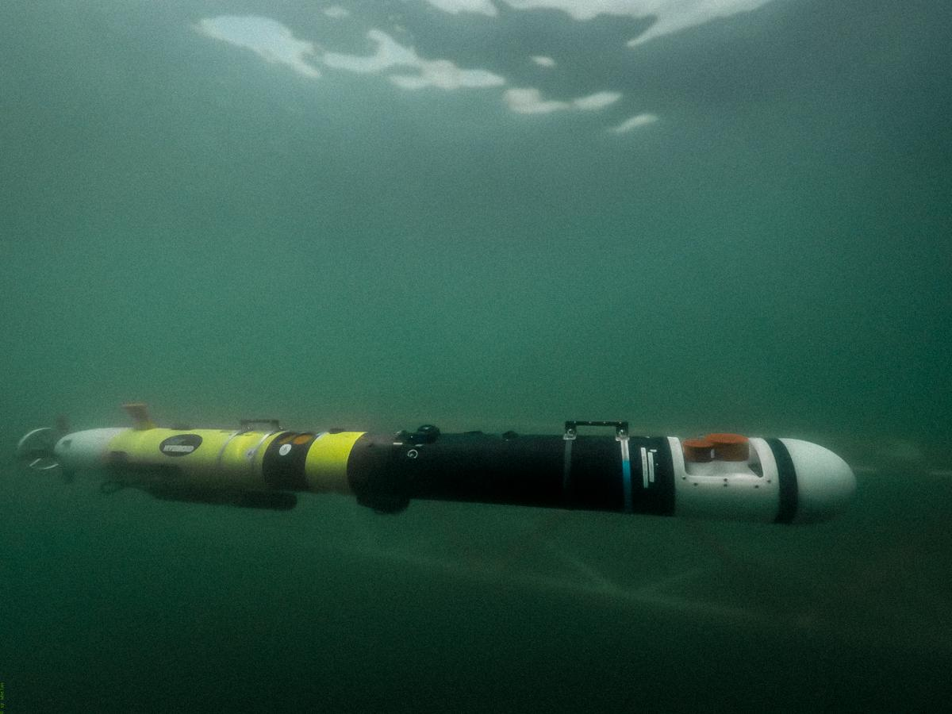

AUV Snoopy with EK80 WBT-Mini (220 split, 333 single narrow-beam, broadband echosounder), Suna V2 nitrate, Ecopuck triplet, NBOSI CT, up-looking camera, ADCP, Dissolved oxygen sensor.

* Length: ~6’
* Weight: ~200lbs

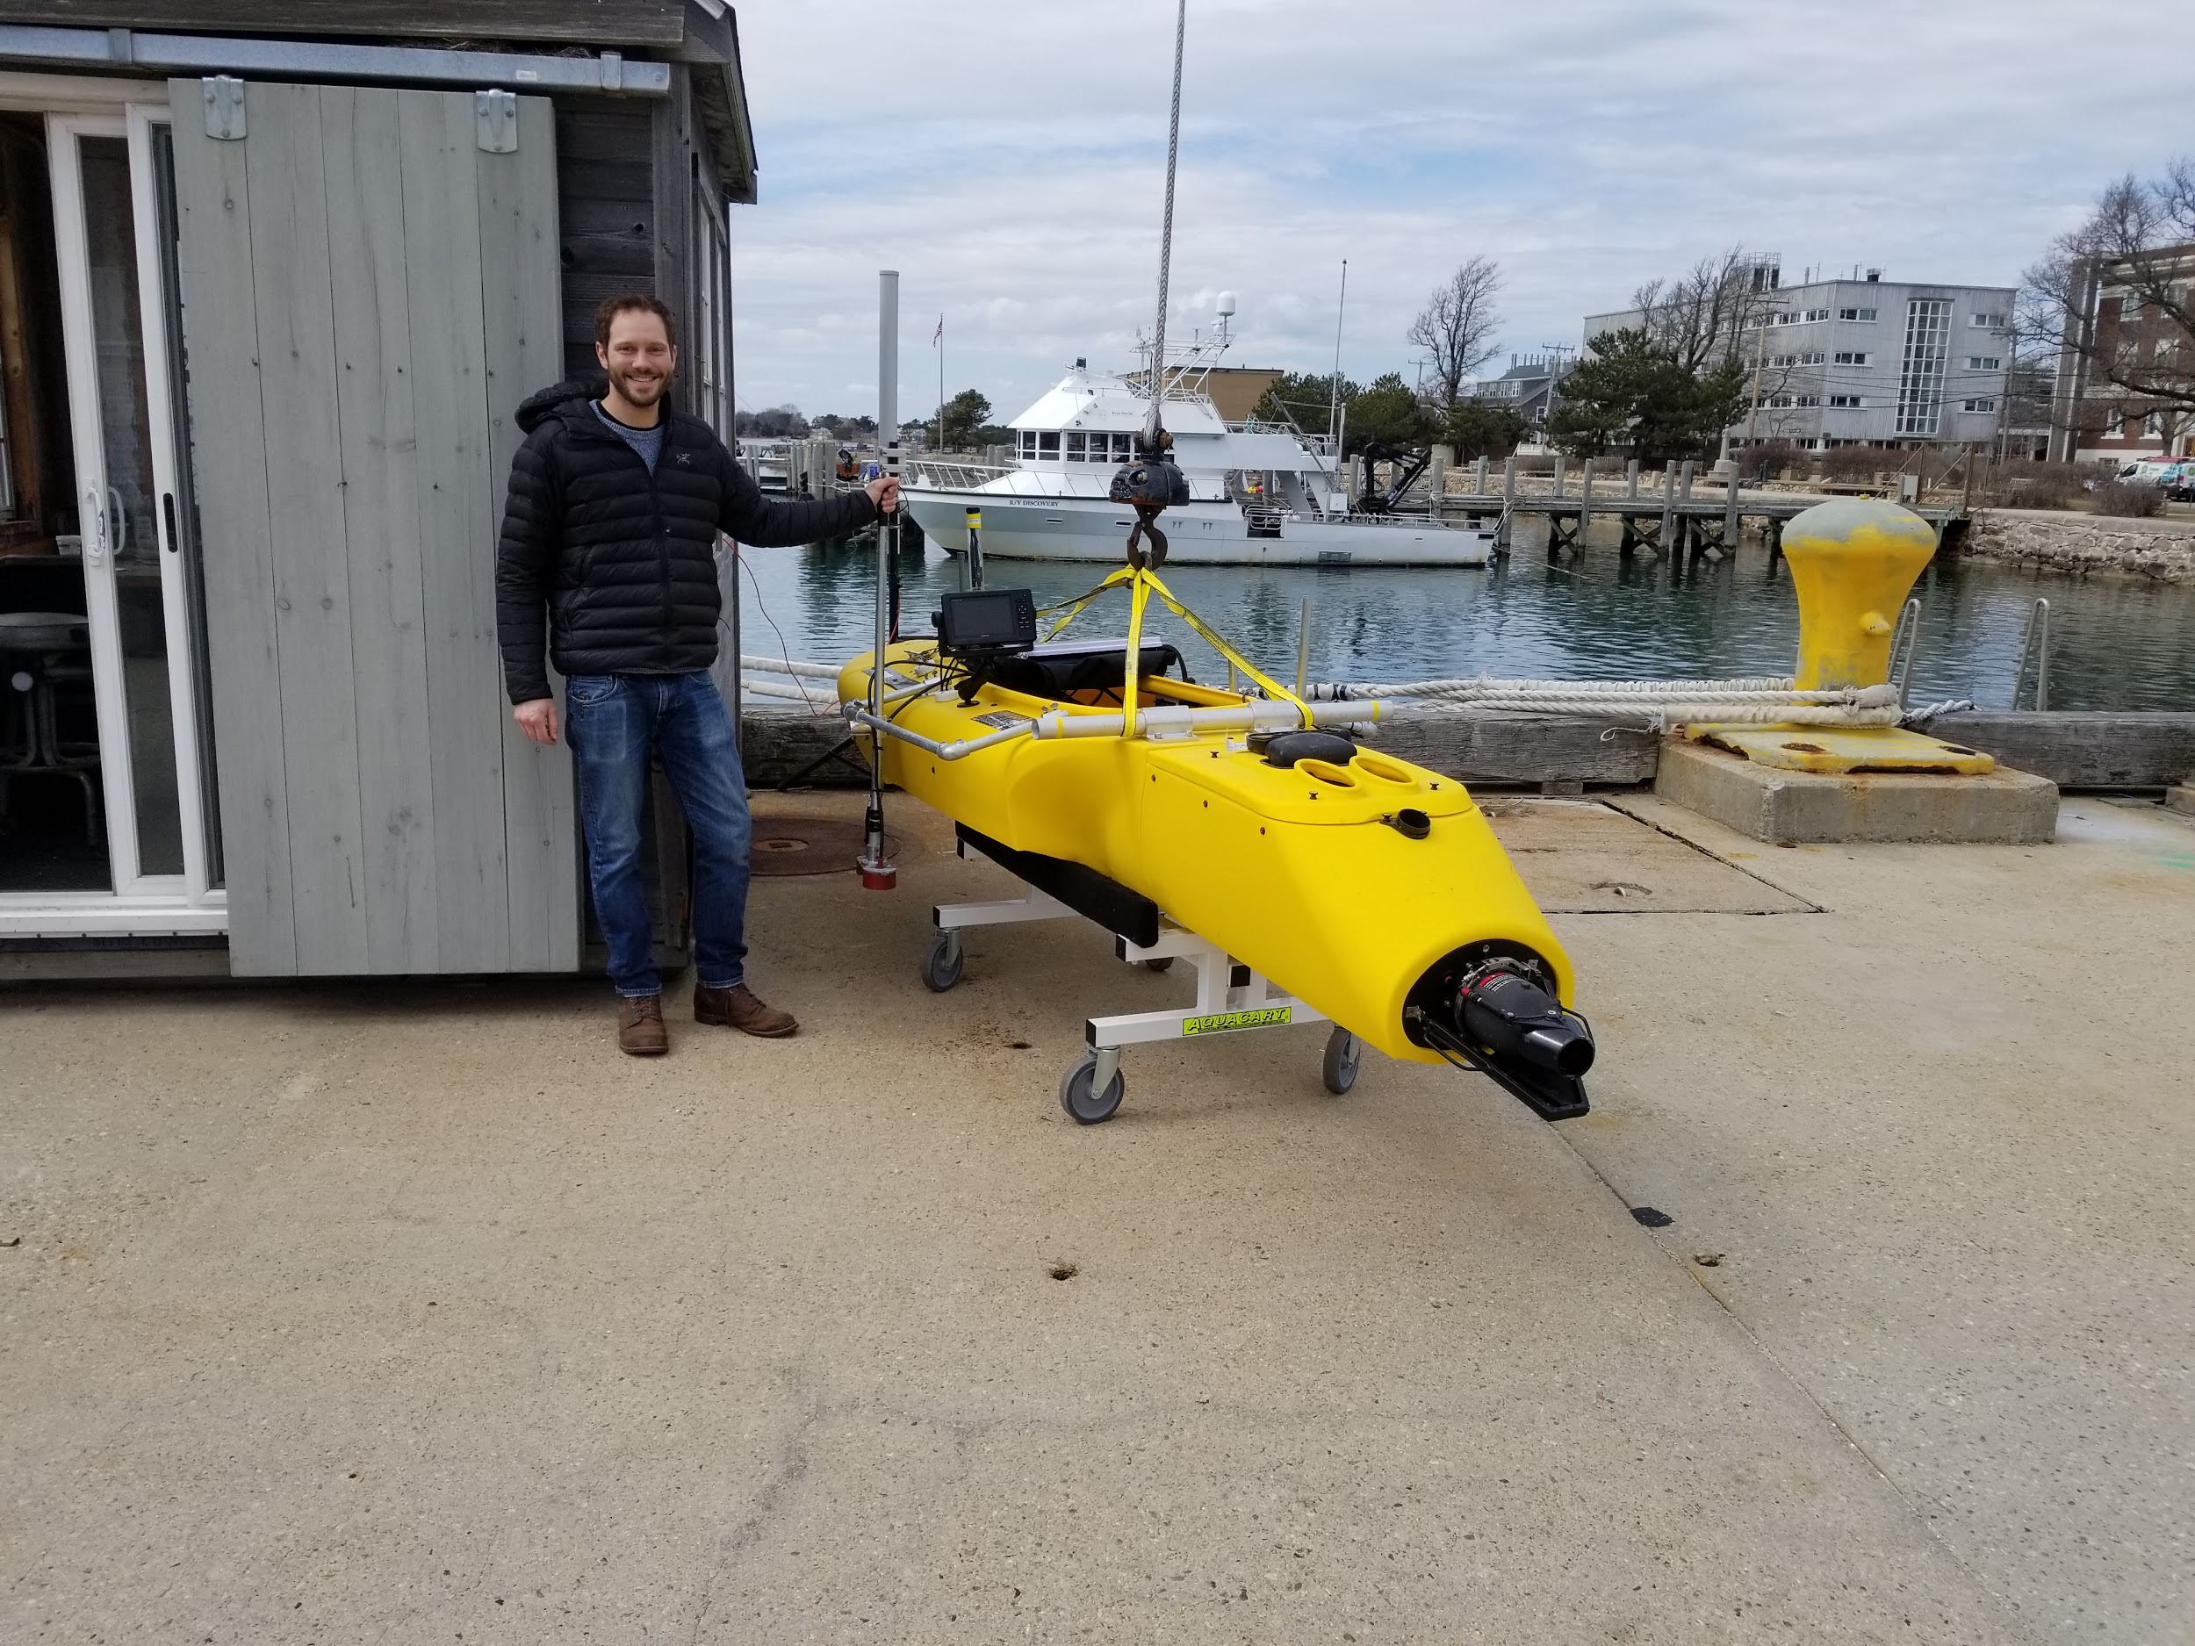

JetYak ASV withJetYak ASV with EK80 WBT-Mini, Ping echosounder

* Length:
* Width:
* Weight:

Kelpcam stand-alone camera

ROV

WHOI’s boat RV Hurricane (7 m RHIB)

***General Operation Plan***

*Boat:* WHOI will trailer the Hurricane with us to the sites. In addition, the UNE boat will be used for operations at UNE, as it will fit the JetYak onboard. The UNH boat (22’) can be used for ROV and KelpCam operations.

*General Missions:* Lawnmower under kelp with AUV, over kelp with ASV, surrounding farm with AUV for peripheral environmental data.

***UNE:***

The AUV can have overnight space where prepped last year, dock in water to keep jetyak and boat overnight. Access across the water to camp ellis for parking trucks etc. We want access to a card to get in/out of electronic gate- they will get us access.

**UNE Contact Info**:

Liz Johndrow- office: (207)-602-2481 cell (860)977-7594, [kjohndrow@une.edu](mailto:kjohndrow@une.edu), office#132

Marine Science Center

Adam St. Gelais- (207)-221-4148 [astgelais@une.edu](mailto:astgelais@une.edu)

UNE Marine Science Center: 11 Beach Hills Rd. Biddeford, ME 04005, the last building on the campus, left hand side of the street.

***UNH:***

They will find space at the pier, there is a storage facility for AUV/ASV for the night that is close to the dock. (Offload boat, charge vehicle).

***Site Information:***

**Site 1: UNE in-shore**

***GPS:***

**WOOD Crownline East 43.454735 -70.336514**

**WOOD Eastern Corner Float 43.454767 -70.336783**

**WOOD E1 Lollipop Float 43.454787 -70.33699**

**WOOD M2 Lollipop Float 43.454813 -70.337187**

**WOOD W3 Lollipop Float 43.454826 -70.337376**

**WOOD Western Corner Flaot 43.454846 -70.337591**

**WOOD Western Crownline 43.454872 -70.337969**

*Information:* 15 minute transit, protected. Same as last year. JetYak only. Single line, 200 ft.

*Water Depth:* 20ft mean, 24ft high/15ft low.

*Current and Tides:*

*Desired Surveys:* ASV: over-line lawn-mowers with multiple crossings at different angles, two different sensor depths (Kevin- adjust depth between surveys). AUV: drive around farm area to collect environmental data surrounding farm- water is too shallow for save under-line operations.

*Obstructions/keep-out:* GPS coordinates

**Site 2: UNE exposed**

***GPS:***

**RAM West Crownline 43°28'18.80"N 70°21'4.30"W**

**RAM West Mooring 43°28'18.20"N 70°21'4.70"W**

**RAM Depth Control West 43°28'18.60"N 70°21'0.70"W**

**RAM Depth Control Middle 43°28'18.80"N 70°20'54.46"W**

**RAM Depth Control East 43°28'18.70"N 70°20'54.46"W**

**RAM East Corner Floatation 43°28'18.60"N 70°20'54.46"W**

**RAM East Anchor 43°28'19.30"N 70°20'55.62"W**

**RAM East Crownline 43°28'19.50"N 70°20'54.00"W**

*Information:* More exposed, more depth. Will provide salinity and temperature. Lobster boats nearby but should not be a significant issue.

*Water depth:* 50ft mean, 55ft high/ 45ft low

*Current and tides:* 0.5 kt

*Desired Surveys:* AUV: under line survey in lawnmower in direction crossing the line at ~90 degree and then ~45 degree angle. Several different AUV depths for acoustic survey with acoustics. AUV “around-site” survey.

*Obstructions/keep-out:* Island relatively close by

**Site 3: Inshore UNH lines**

***GPS:*** IMTA kelp line (UNH): (43.069867, -70.708333) (443.069450, -70.708900); WHOI/UNH line: (43.069383, -70.708383) (43.068867,-70.709017)

*Information:* Both single and multi-lines. Kelp is 2m long, Scott has multi-line system next to it, 5 lines total, 4 kelp lines and 1 guide line. IMTA raft also there on 2-point mooring, with heavy mussel lines and some kelp on the mussel droppers. 2.5 miles protected transit to inshore site, run both the AUV and ASV

Boat traffic, wakes may be an issue.

*Water Depth:* Lines at 2-3 m depth, low tide 7 m water depth, high tide 10 m water depth.

*Current and tides:* Strong current- up to 0.5 m/s, depending on time of day, 2 kt current.

*Desired Surveys:*  Cross under all lines perpendicular at max safe AUV depth. Circle around site with AUV. Down-looking from JetYak (towed out from shore), crossing lines. AUV “around-site” survey with yoyo. ASV from-above survey of lines, drive-around of raft.

*Obstructions/keep-out:*

**Site 4: Offshore UNH line**

**GPS:** 42.59.316 DMS, 70.37.196 DMS, 42.59.346 DMS, 70.37.172 DMS

*Information:* Single line offshore appledore, growing great. May be waves, but protected unless winds are from the west.

*Water Depth:* 40’,

*Currents and tides:* 1 kt currents

*Desired Surveys:* AUV Cross under line perpendicular, repeated along length. Cross at 45 lawnmower. Surround-site survey with yoyo.

*Obstructions/keep-out:*

**Site 5: Isle of Shoals Mussel farm**

*Moorings:* (42.960833, -70.710083), (42.967833, -70.697517), (42.969530, -70.700200), (42.960933, -70.706867)

*Water depth:*  120 ft water depth.

*Currents and tides:*

*Information: V*ery exposed, mussel lines are all over the place. Backbone line between blocks, clusters of buoys 10 m below surface, 500 ft length of backbone line, dropper lines 3m long below backbone, 2 m spaced.

*Desired survey*: Any information/mapping we can provide- sidescan on Snoopy?

If time, survey to find blocks.

*Obstructions/keep-out:*

***Science objectives:***

Acoustics:

* Baseline comparison between sonars for lines with kelp on them.
* Evaluate EK80 ability to detect kelp on lines, assess variability across field, and provide frequency-dependent information for kelp and fish scattering from below and above.
* Assess EK80/Ping on ASV and EK80 on AUV based on range to kelp: vary sensor depth (AUV multi-depth mission, ASV lower pole).
* Assess acoustic variability in EK80 and Ping from ASV, EK80 on AUV (Repeat passes over same line).

Structural engineering:

* Line locations/behavior v. time?

Environmental data:

* Variability of Nitrate, salinity, D O2, temperature etc. over entire farm site mapping, correlation with growth?
* Variability v. depth?
* Upstream v. downstream?

Camera:

* Assess Kelpcam for resolving lines and kelp at different ranges at different sites.
* Collect data to use for development of processing chains.

Data we will collect:

* Snoopy:
  + Each site: Lawnmower survey under each site at 2 depths with AUV, crossing the lines approximately perpendicular to the line direction.
  + One site: Lawnmower survey at 1 depth with AUV, at 45 degree angle to the line direction.
  + One site: Lawnmower survey at 1 depth approximately aligned with the lines.
  + Continuous collection of ADCP, Nitrate, Ecopuck, CT, up-looking camera data throughout farm
  + Square/circle/other surround-based survey around farm site with depth yo-yo collecting all sensor data (upstream/downstream data).
* JetYak:
  + Survey (weather permitting) perpendicular to, at 45 degree angle, and approximately aligned with longlines.
* Kelpcam:
  + Camera-on-a-line inspection of lines/kelp.